
FACULTY OF TECHNOLOGY AND ENGINEERING
DEVANG PATEL INSTITUTE OF ADVANCE TECHNOLOGY
AND RESEARCH

DEPARTMENT OF COMPUTER ENGINEERING

A.Y 2026 – 27 Semester – 3

LAB MANUAL

CSUC201 Fundamentals of Data Structures and Algorithms

Practical 1: Array Operations: Traversal, Rotation, and Frequency Analysis

Practical Aim: To implement fundamental array operations.
Problem 1 :
A bakery prepares n items every morning and places them in a display row. At the end of each hour, the leftmost item is moved to the rightmost position to make room for fresh stock at the front. Given the initial row and the number of hours h, print the final display order. Describe the approach you used. How does it behave when h is very large, say 10 million? Is there a way to get the correct result without performing the operation h times?

For Code:
GitHub Repo Link:
https://github.com/meet-3834/FDSA/tree/main/Practicals/Practical%201

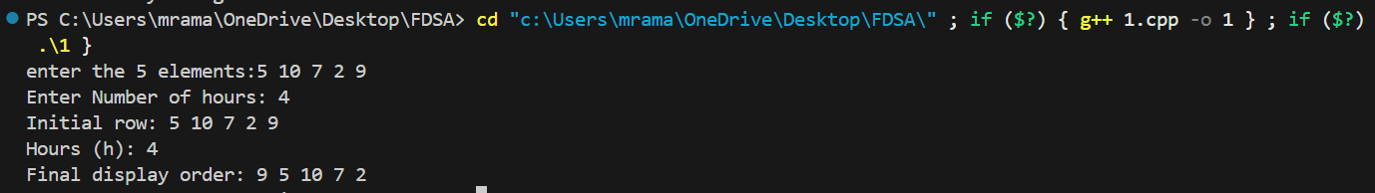
Output:

Problem 2 :
A library issues books to students and records each book's ID every time it is borrowed. At the end of the month, the librarian wants to find all books that were borrowed more than once, as those need priority restocking. Given the borrowing log, print all such book IDs.
Describe the approach you used. How many times does your solution scan the data? If the library had 100,000 borrow records, would your approach still be practical? Can you think of a way that requires fewer passes?
For Code:
GitHub Repo Link:
https://github.com/meet-3834/FDSA/tree/main/Practicals/Practical%201
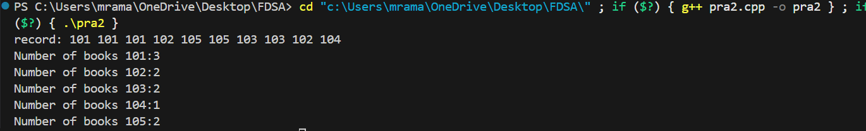
Output:

Problem Faced:

Problem 3 :
A school newspaper editor wants to highlight the most impressive word from a submitted article on the front page. The word is chosen simply by length - the longest one wins. Given a sentence, print the winning word and how many letters it has.
Describe the approach you used. What does your solution do when two words have the same length? Is that behavior intentional, and can you think of a way to handle it explicitly?

For Code:

GitHub Repo Link:
https://github.com/meet-3834/FDSA/tree/main/Practicals/Practical%201
Output:

Key Questions / Analysis / Interpretation to be Evaluated During/After:
Implementation
- [Problem 1] The display order repeats itself after a certain number of hours regardless of how large h gets. Without trying any specific example, explain why this repetition is inevitable and what determines when it first repeats.
Sol:
The display order repeats after n rotations because all items return to their original positions. Therefore, the first repetition occurs after n rotations.

- [Problem 2] If the same book ID appears three times in the log, should it appear once or three times in your output? Does your solution handle this correctly, and how would you verify it?

Sol:
If a book ID appears three times, it should be printed only once. The frequency map ensures this by checking counts instead of printing every occurrence.

- [Problem 3] The editor later decides that punctuation attached to a word (e.g. "hello," or "great!") should not count toward its length. How would this change your solution, and at which step would you handle it?
Sol:
If punctuation should not be counted, remove punctuation from each word before calculating its length. This ensures accurate results.

Outcome/Conclusion:
I am able to apply array operations to solve real-world problems, identify inefficiencies in naive approaches, and articulate alternative strategies even when full implementation is beyond current scope.

